Appendix 1 - Footfall Oxford 2018

Overview Oxford Quarterly Reports 2016-2017- 2018
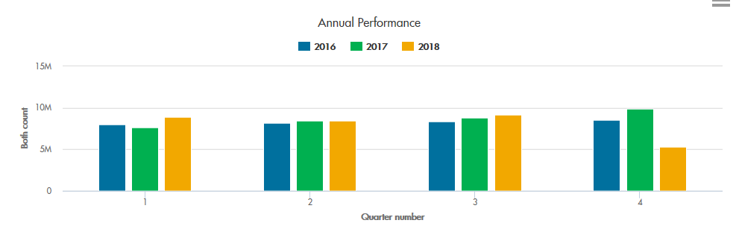
The long term trend of steady and increase in footfall overall over Oxford during the first 3 Quarters of 2018

Change of footfall:
Quarter 1:
2017 4.6% down on the previous year
2018 15.9% up on the previous year
Quarter 2:
2017 2.3% up on the previous year
2018 0.5% up on the previous year
Quarter 3:
2017 5.4% up on the previous year
2018 4.2% up on the previous year
Quarter 4:
2017 15.4% up on the previous year

Footfall UK 2018

Quarter 1 2018
Footfall declined by -3.0% in Q1 2018, a significantly worse result than the drops of -1.9% in Q4 2017 and -0.2% in Q1 2017.
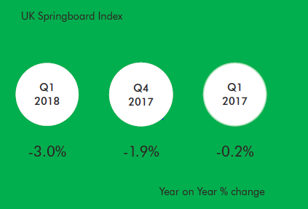

Quarter 2 2018
Footfall declined by -1.5% in Q2 2018, an improvement on the drop of -3.0% in the previous quarter, but a noticeable worsening from Q2 2017 when footfall rose by +0.5%.
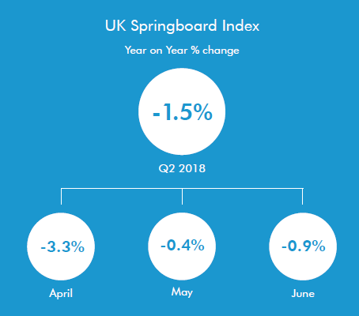

Quarter 3 2018
Footfall declined by -1.4% in Q3 2018, a marginal improvement on the drop of -1.5% in the previous quarter, but a slight worsening from Q3 2017 when footfall declined by -1.2%.
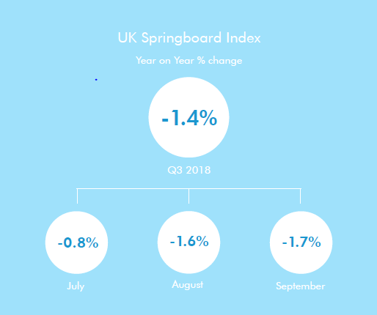

The decline in footfall in Q3 was virtually universal across all geographies bar one, where footfall was flat.
This is a continuation of a trend that was evident in both Q2 2018 and in Q3 2017, however the magnitude of the decline worsened this quarter in six of the ten geographies.
The most severe falls occurred in the east and the west of the UK (-2.9% in the East, -3.4% in the East Midlands, -2.5% in the South West and -3.4% in Wales). In just one geography the decline in footfall was less than -1.0% (-0.8% in Greater London).
In virtually all geographies footfall worsened noticeably in August and September, with footfall in six areas of the UK declining by more than -3.0% in September.
